**Name : Murali srinivasan S  
Dept : CSE  
Test : Practice_Set_03**

1. Check if two strings are anagrams of each other  
     
   **Code :  
     
   import java.util.*;  
     
   class Example{**

**public static void main(String[] args){**

**System.out.println(checkAnagrams(“abcd”, “dacb”));**

**}**

**public static boolean checkAnagrams(String s, String t){**

**HashMap<Character, Integer> count_mp = new HashMap<>();**

**for(char c : s.toCharArray()){**

**count_mp.put(c, count_mp.getOrDefault(c,0)+1);**

**}  
  
 for(char c : t.toCharArray()){**

**count_mp.put(c, count_mp.getOrDefault(c,0)-1);**

**}**

**for(var pair : count_mp.entrySet()){**

**if(pair.getValue() != 0){**

**return false;**

**}**

**}**

**return true;**

**}**

**}**

**Complexities :**Time Complexity : O(m + n)

Space Complexity : O(1)  
  
**Output :**  


1. Find the row with maximum number of 1s  
   **Code :  
     
   import java.util.*;**

**class Example{**

**public static void main(String[] main){**

**int[][] mat = { {0, 0, 0, 1},**

**{0, 1, 1, 1},  
 {1, 1, 1, 1},  
 {0, 0, 0, 0} };**

**System.out.println(“Index of row with maximum 1s : ” + maxOneRow(mat, mat.length, mat[0].length));**

**}**

**public static int maxOneRow(int[][] mat, int r, int c){**

**boolean flag = true;**

**int row_index = 0, max_ones = 0;**

**for(int i=0; i<r; i++){**

**int cnt = 0;**

**for(int j=0; j<c; j++){**

**if(mat[i][j] == 1){ cnt++; flag = false; }**

**if(cnt > max_ones){**

**max_ones = cnt;**

**row_index = i;**

**}**

**}**

**}  
  
 if(flag){ return -1; }  
  
 return row_index;**

**}**

**}**

**Complexities :**Time Complexity : O(r*c)

Space Complexity : O(1)

**Output :**

1. Longest Consecutive Subsequence  
     
   **Code :  
     
   import java.util.*;  
     
   class Example{**

**public static void main(Sting[] args){**

**int[] arr = {-3,-1,0,-2,4,1,5};  
 int n = arr.length;**

**System.out.println(longestSubsequence(arr, n));  
}**

**public static int longestSubsequence(int[] arr, int n){  
  
 Arrays.sort(arr);**

**int count = 0;**

**int ans = 0;**

**ArrayList<Integer> ls = new ArrayList<Integer>();**

**for(int i=1; i<n; i++){**

**if(arr[i] != arr[i-1]){ ls.add(arr[i]); }**

**}  
  
 for(int j=1; j<ls.size(); j++){  
 if(ls.get(j-1)+1 == ls.get(j)){**

**count++;**

**ans = Math.max(ans, count);**

**}**

**else{ count = 1; }  
 }  
  
 ans++;**

**return ans;  
}**

**}**

**Complexities :**Time Complexity : O(n log n)

Space Complexity : O(n)

**Output :**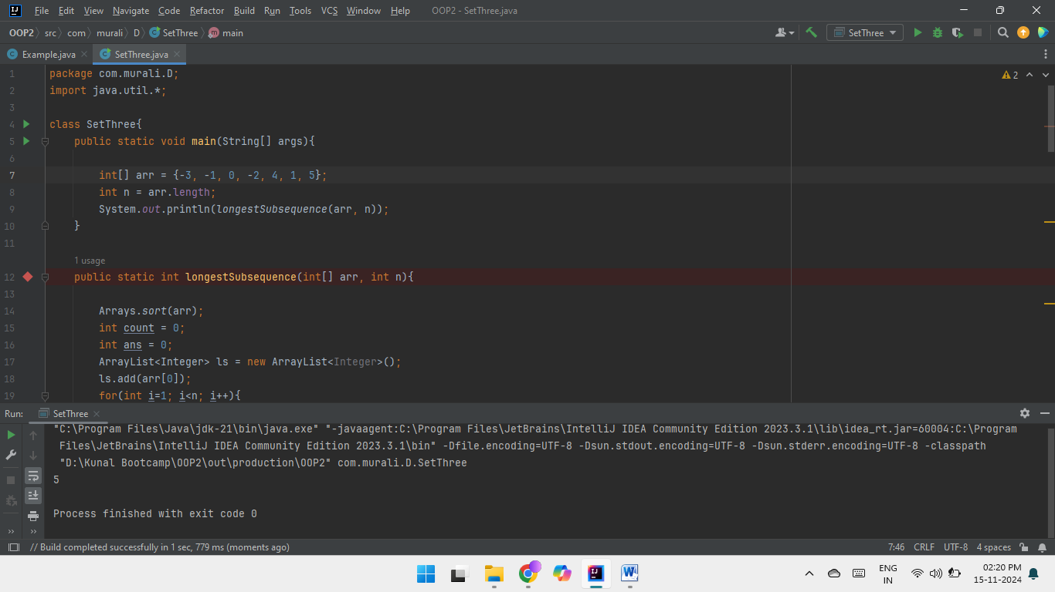

1. Longest Palindromic SubString  
     
   **Code :  
     
   public class Example {  
     
    public static void main(String[] args) {**

**String s = "forgeeksskeegfor";**

**System.out.println(longestPalSubstr(s));**

**}**

**static String longestPalSubstr(String s) {**

**int n = s.length();**

**int maxLen = 1, start = 0;**

**for (int i = 0; i < n; i++) {**

**for (int j = i; j < n; j++) {**

**if (checkPal(s, i, j) && (j - i + 1) > maxLen) {**

**start = i;**

**maxLen = j - i + 1;**

**}**

**}**

**}**

**return s.substring(start, start + maxLen);**

**}**

**public static boolean checkPal(String s, int low, int high) {**

**while (low < high) {**

**if (s.charAt(low) != s.charAt(high))**

**return false;**

**low++;**

**high--;**

**}**

**return true;**

**}**

**}**

**Complexities :**Time Complexity : O(n^3)

Space Complexity : O(1)

**Output :**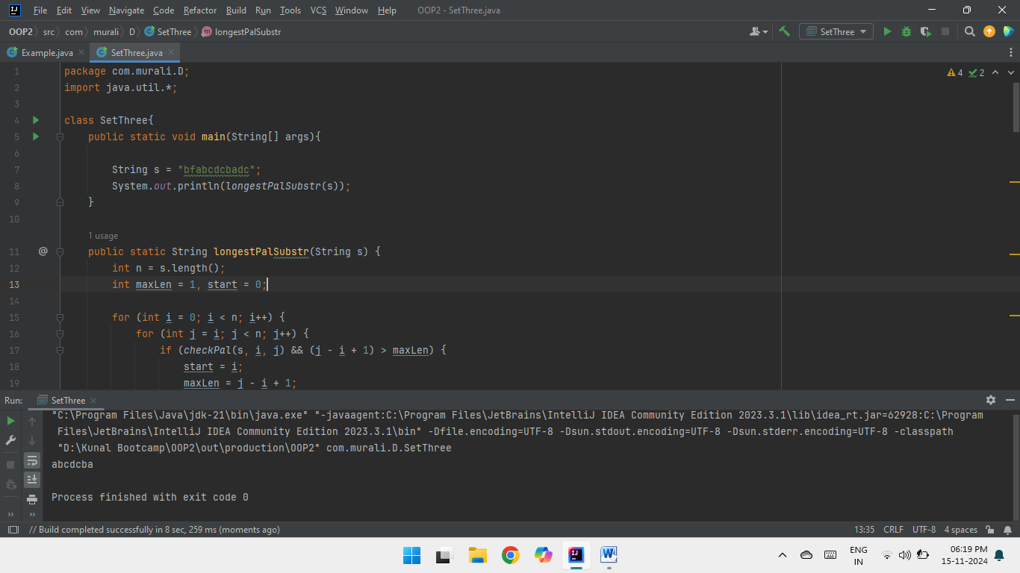

1. Rat in a Maze Problem  
     
   **Code :  
     
   import java.util.*;**

**class MazePaths{  
  
 public static int k = 1;**

**public static void main(String[] args){**

**int[][] maze = { { 1, 0, 0, 0 },**

**{ 1, 1, 0, 1 },**

**{ 1, 1, 0, 0 },**

**{ 0, 1, 1, 1 } };**

**allPathsMatrix("", maze, 0, 0);**

**}**

**public static void allPathsMatrix(String p, int[][] maze, int r, int c) {**

**if (r == maze.length-1 && c == maze[0].length-1) {**

**System.out.println(k + ". " + p);**

**k++;**

**return;**

**}**

**//Because 0-Based indexing .**

**if(maze[r][c] == 0 || maze[r][c] == -2){**

**return;**

**}**

**maze[r][c] = -2;**

**if (c < maze[0].length-1){**

**allPathsMatrix(p + "R", maze, r, c+1);**

**}**

**if (r < maze.length-1){**

**allPathsMatrix(p + "D", maze, r+1, c);**

**}**

**if (c > 0){**

**allPathsMatrix(p + "L", maze, r, c-1);**

**}**

**if (r > 0){**

**allPathsMatrix(p + "U", maze, r-1, c);**

**}**

**maze[r][c] = 1;**

**}  
 }**

**Complexities :**Time Complexity : O(3^(m*n))

Space Complexity : O(m*n)  
  
**Output :**